Table of Contents

1.0 Introduction

1.1 Purpose of the document

1.2 Definitions and Acronyms

**1.3 Project Overview**

**1.4 In Scope**

**1.5 Intended Audience**

**1.6 Constraints, Assumptions and Dependencies**

**1.7 Hardware and Software Requirements**

**1.8 Screen Flow**

**2.0 Use Cases and Web Interface**

**2.1 Main Home Page**

**2.2 Student Login Page**

**2.3 Student Home Page**

**2.4 Staff Login Page**

**2.5 Staff Home**

**2.7 Student Data updation**

**2.8 View All Students**

**2.9 Check Uploaded PDFs**

**2.10 Admin Login**

**2.11 Admin Home Page**

**2.12 Staff Det Registration Page**

**2.13 Staff Data Updation**

**2.14 View All Staff – Staff Side**

**2.15 Staff Portal Registration Page**

**2.16 Staff Portal Updation**

**2.17 Student Portal Registration**

**2.18 Student Portal Updation Page**

**2.19 View All Students**

**2.20 Logout**

3.0 Standards and Guidelines 10

4.1 HTML 10

4.2 CSS 11

4.3 Java Script 11

# Introduction

## Purpose of this document

The purpose of this document is to define the use cases for Online E-Book Management System portal application.

## Definitions & Acronyms

|  |  |
| --- | --- |
| Definition / Acronym | Description |
| CDW | College Department Website – To Sub IA PDFs |
| HTML | Hyper Text Markup Language |
| CSS | Cascading Style Sheet |

## Project Overview

College Department Website is a system which maintains the details about the staff and students present in the department. This is very difficult to monitor manually as a doc . Maintenance of all this information manually is a very complex task. Owing to the advancement of technology, organization of a College becomes much simple. It has been designed according to the staff details and student details functionalities that are to be performed.

This platform can offer the staff to view the submitted PDFs, perform updation of student’s data. Through this, it reduces the workload of management as most of the manual work done will be reduced.

## In Scope

Following are the key features that needs to be implemented for Students , Staff and Admin are :

Student

1. Submit PDF
2. View All PDFs

Staff

1. Add New Student Details
2. Update Student Details
3. View All Student Details
4. View Uploaded PDFs

Admin

1. Add Staff Details
2. Update Staff Details
3. View All Staff
4. Add Staff Portal Data
5. Update Staff Portal Data
6. Add Student Portal Data
7. Update Student Portal Data

## Intended Audience

* Product Owner
* Scrum Master
* Application Architect
* Project Manager
* Test Manager
* Development Team
* Testing Team

## Constraints, Assumptions and Dependencies

**Assumptions**

Admin used ID and password will be given by the maintaince team.

**Dependencies**

None

**Constraints**

None

## 1.7 Hardware and Software Requirement

**Hardware Requirements:**

Processor: intel i5.

* RAM Capacity: 4 GB
* Hard Disk: 500 GB.

**Software Requirements:**

* Operating System: Windows 10.
* Browser: Google Chrome.
* Database Server: My SQL.
* Backend: Spring Boot MVC, Hibernate
* Frontend: HTML 5, CSS 3, JSP
* IDE: Spring Tool Suite 4.0
* Reference application access steps
  1. Login into <https://localhost:8080/home.com>
  2. Click “Commits”
  3. Click “Browse Files” option on “web module”
  4. This Page will show you the home page of E-Book management System.

## Screen Flow

Flow of screens for Student, Staff and Admin provided below. Blue boxes represent pages. Orange boxes represent the user role. The label in the lines denote the link in the page used to arrive from the specific page.

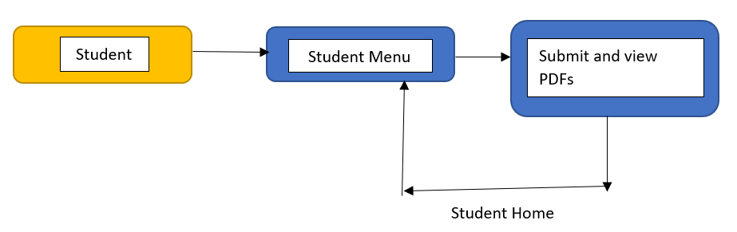

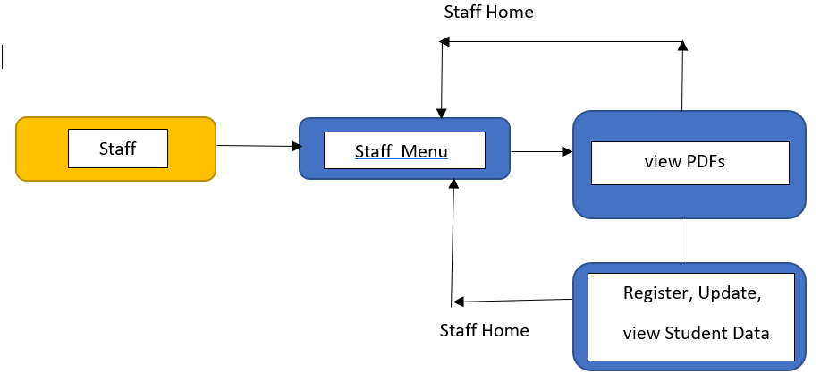

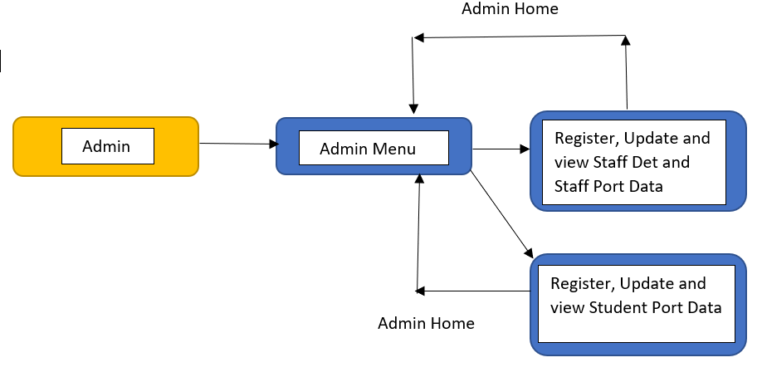

# Use Cases

There will be the types of users whom will be using this application:

1. Student
2. Staff
3. Admin

Student – Specifically meant to upload the IA PDFs and view the submitted PDFs only.

Staff – Responsible for managing the student details and the uploaded PDFs.

Admin – Responsible for managing the whole portal data of both students and staff(UserID and Password). Only admin will be able to add and update the details of the staff.

Find below the list of use case diagram that represents the list of Use Cases that needs to be incorporated.

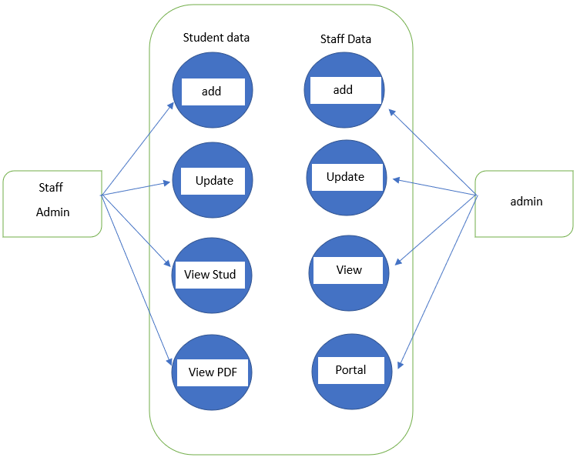

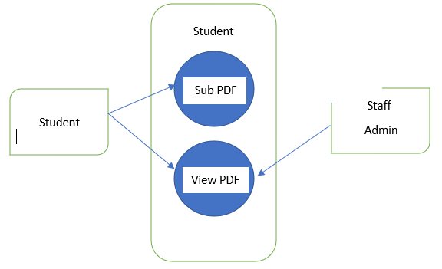

## Main Home Page

|  |  |
| --- | --- |
| Use Case ID | CDW1 |
| Use Case Name | Main HomePage |
| Actor(s) | Student and Staff Accordingly |
| Description | Students and Staff has the previleage to view the home page of the Application |
| Pre-condition | Students and Staff should have privilege to home page application and should access the url of the application Online . |
| Post-Condition | Student and Staff can use the options of the respective page |
| Basic Path | Student opens the browser and browses the application url and will be able to use the application. |

In this page Students and Staff can access the following options.

## Student Login Page

In this page Student can login

|  |  |
| --- | --- |
| Use Case ID | CDW2 |
| Use Case Name | Student Login Page |
| Actor(s) | Student |
| Description | Student can enter the post login page entering the credentials. |
| Pre-condition | Student should have priveleage to post login page |
| Post-Condition | After successful login in the application Student can upload and view the PDFs. |
| Basic Path | 1. Student after successful registration of his details can access the login page. 2. In the login page admin should enter login details like:   a)Student USN  b)Password  3. After entering the valid details it leads to successful login.  Otherwise, Enter the valid details to login. |

## Student Home Page

|  |  |
| --- | --- |
| Use Case ID | CDW3 |
| Use Case Name | HomePage(STUDENT) |
| Actor(s) | Student |
| Description | Student can enter the post login page entering the credentials. |
| Pre-condition | Student should have privilege to home page application and should access the url of the application Online . |
| Post-Condition | Student can access all the options available in the staff home page. |
| Basic Path | Student opens the browser and browses the application url, then logs into staff home page using student portal credentials. |

In this page Student can submit and View PDFs.

## Staff Login Page

In this page Staff can login to StaffHomePage

|  |  |
| --- | --- |
| Use Case ID | CDW4 |
| Use Case Name | Staff Login Page |
| Actor(s) | Staff |
| Description | Staff should have privelage to view option on login. |
| Pre-condition | Staff should have priveleage to operate the option in the page |
| Post-Condition | After successful login in the application staff will be able to see the post login page |
| Basic Path | 1. Staff after successful registration of his details can access the login page. 2. In the login page admin should enter login details like:   a)Staff ID  b)Password  3. After entering the valid details it leads to successful login.  Otherwise, Enter the valid details to login. |

## Staff Home Page

|  |  |
| --- | --- |
| Use Case ID | CDW5 |
| Use Case Name | HomePage(STAFF) |
| Actor(s) | Staff and Admin |
| Description | Staff can enter the post login page entering the credentials. |
| Pre-condition | Staff and Admin should have privilege to home page application and should access the url of the application Online amd use the following operations available in there. |
| Post-Condition | Staff and Admin can access all the options available in the staff home page. |
| Basic Path | Staff/Admin opens the browser and browses the application url, then logs into staff home page using staff portal credentials. |

In this page Staff can access the options available from menu

## Student Register Page

Staff will be able to register a new student if required.

|  |  |
| --- | --- |
| Use Case ID | CDW6 |
| Use Case Name | Register Page of Student |
| Actor(s) | Staff |
| Description | In this page Staff can register a Student with his valid details. |
| Pre-condition | In this case Staff can view the Sudent Reg Page of this application  College Department Application. |
| Post-Condition | After Registration, Staff can view the registered details of the Student. |
| Basic Path | 1. After Accessing the url of this application Staff can access the Student Register Page of the Application. 2. In Staff Home Page, Staff can access the url of the register page by clicking on it. 3. After accesing the url Staff can enter the respective details and Register the details. 4. Details provided in Register page:   a)Student USN  b)Student Name  c)DOB  d)Mobile Number  e)Email Address  f)Address  g)DOA |

## Student Details Updation Page

In this page Staff can access the update option if any updation required.

|  |  |
| --- | --- |
| Use Case ID | CDW7 |
| Use Case Name | Updation of Student |
| Actor(s) | Staff |
| Description | In this page Staff can update a Student with his valid details. |
| Pre-condition | In this case Staff can view the Sudent Reg Page of this application  College Department Application. |
| Post-Condition | Staff can access all the options available in the staff home page. |
| Basic Path | 1. After Accessing the url of this application Staff can access the Student Updation Page of the Application. 2. In Staff Home Page, Staff can access the url of the update page by clicking on it. 3. After accesing the url Staff can enter the respective details and update the details. 4. Details provided in Updation page:   a)Student USN  b)Student Name  c)DOB  d)Mobile Number  e)Email Address  f)Address  g)DOA |

## 2.8 View all Students Page

Staff can view the Student details.

|  |  |
| --- | --- |
| Use Case ID | CDW8 |
| Use Case Name | View All Students Page |
| Actor(s) | Staff |
| Description | Staff should have privelage to view the Student details . |
| Pre-condition | Staff should have priveleage to view the View all student Page. |
| Post-Condition | Staff will be able to see all the registered students |
| Basic Path | 1. After Accessing the url of this application Staff can access the View all Students of the Application. 2. In Staff Home Page, Staff can access the url of the view all students by clicking on it. 3. After accesing the url Staff can enter the respective details and view the students 4. Details provided in the page:   a)Student USN  b)Student Name  c)DOB  d)Mobile Number  e)Email Address  f)Address  g)DOA |

## 2.9 Check Uploaded PDFs

Staff can view the Student’s PDFs.

|  |  |
| --- | --- |
| Use Case ID | CDW9 |
| Use Case Name | Check uploaded PDFs |
| Actor(s) | Staff |
| Description | Staff should have privelage to view the PDFs . |
| Pre-condition | Staff should have priveleage to view the View all student’s PDFs. |
| Post-Condition | Staff will be able to see all the submitted PDFs |
| Basic Path | 1. After Accessing the url of this application Staff can access the View all PDFs of the Application. 2. In Staff Home Page, Staff can access the url of the view all pdfs by clicking on it. 3. After accesing the url Staff can enter the respective details and view the PDFs 4. Details provided in the page:   a)Student USN  b)Student Name  d)Email Address  e)Mobile Number  f)Semester  g)Test Number  h)PDFs |

## Admin Login Page

In this page Admin can login to AdminHomePage

|  |  |
| --- | --- |
| Use Case ID | CDW10 |
| Use Case Name | Admin Login Page |
| Actor(s) | Admin |
| Description | Admin should have privelage to view option on login. |
| Pre-condition | Admin should have priveleage to operate the option in the page |
| Post-Condition | After successful login in the application Admin will be able to see the post login page |
| Basic Path | 1. Admin after successful registration of his details can access the login page. 2. In the login page admin should enter login details like:   a)Admin ID  b)Password  3. After entering the valid details it leads to successful login.  Otherwise, Enter the valid details to login. |

## Admin Home Page

|  |  |
| --- | --- |
| Use Case ID | CDW11 |
| Use Case Name | HomePage(ADMIN) |
| Actor(s) | Admin |
| Description | Admin can enter the post login page entering the credentials. |
| Pre-condition | Admin should have privilege to home page application and should access the url of the application Online amd use the following operations available in there. |
| Post-Condition | Admin can access all the options available in the Admin home page. |
| Basic Path | Admin opens the browser and browses the application url, then logs into admin home page using the credentials given by the developer team. |

In this page Admin can access the options available from menu

## Staff Register Page

Admin will be able to register a new staff if required.

|  |  |
| --- | --- |
| Use Case ID | CDW12 |
| Use Case Name | Register Page of Staff |
| Actor(s) | Admin |
| Description | In this page Admin can register a Staff with his valid details. |
| Pre-condition | In this case Admin can view the Staff Reg Page of this application  College Department Application. |
| Post-Condition | After Registration, Admin can view the registered details of the Staff. |
| Basic Path | 1. After Accessing the url of this application Admin can access the Staff Register Page of the Application. 2. In Admin Home Page, Admin can access the url of the register page by clicking on it. 3. After accesing the url Admin can enter the respective details and Register the details. 4. Details provided in Register page:   a)Staff ID  b)Staff Name  c)DOB  d)Mobile Number  e)Email Address  f)Address  g)DOJ |

## Staff Details Updation Page

In this page Admin can access the update option if any updation required.

|  |  |
| --- | --- |
| Use Case ID | CDW13 |
| Use Case Name | Updation of Staff |
| Actor(s) | Admin |
| Description | In this page Admin can update a Staff with his valid details. |
| Pre-condition | In this case Admin can view the Staff Reg Page of this application College Department Application. |
| Post-Condition | Admin can access all the options available in the Admin home page. |
| Basic Path | 1. After Accessing the url of this application Admin can access the Staff Updation Page of the Application. 2. In Admin Home Page, Admin can access the url of the update page by clicking on it. 3. After accesing the url Admin can enter the respective details and update the details. 4. Details provided in Updation page:   a)Staff ID  b)Staff Name  c)DOB  d)Mobile Number  e)Email Address  f)Address  g)DOJ |

## 2.14 View all Staff Page

Admin can view the Staff details.

|  |  |
| --- | --- |
| Use Case ID | CDW14 |
| Use Case Name | View All Staff Page |
| Actor(s) | Admin |
| Description | Admin should have privelage to view the Staff details . |
| Pre-condition | Admin should have priveleage to view the View all staff Page. |
| Post-Condition | Admin will be able to see all the registered staff |
| Basic Path | 1. After Accessing the url of this application Admin can access the View all Staff of the Application. 2. In Admin Home Page, Admin can access the url of the view all staff by clicking on it. 3. After accesing the url Admin can enter the respective details and view the staff 4. Details provided in the page:   a)Staff ID  b)Staff Name  c)DOB  d)Mobile Number  e)Email Address  f)Address  g)DOJ |

## 2.15 Staff Port Register Page

Admin will be able to register a new staff Port if required.

|  |  |
| --- | --- |
| Use Case ID | CDW15 |
| Use Case Name | Register Page of Staff Port |
| Actor(s) | Admin |
| Description | In this page Admin can register a Staff Port with his valid details. |
| Pre-condition | In this case Admin can view the Staff Port Reg Page of this application College Department Application. |
| Post-Condition | After Registration, Admin can view the registered Portal details of the Staff. |
| Basic Path | 1. After Accessing the url of this application Admin can access the Staff Port Register Page of the Application. 2. In Admin Home Page, Admin can access the url of the register page by clicking on it. 3. After accesing the url Admin can enter the respective details and Register the Port details. 4. Details provided in Student Portal Register page:   a)Staff ID  b)Staff Name  c)DOJ  d)Mobile Number  e)Email Address  f)Password |

## Staff Port Details Updation Page

In this page Admin can access the update option if any updation required.

|  |  |
| --- | --- |
| Use Case ID | CDW16 |
| Use Case Name | Updation of Staff Port |
| Actor(s) | Admin |
| Description | In this page Admin can update a Staff Port with his valid details. |
| Pre-condition | In this case Admin can view the Staff Port Reg Page of this application College Department Application. |
| Post-Condition | Admin can access all the options available in the Admin home page. |
| Basic Path | 1. After Accessing the url of this application Admin can access the Staff Port Updation Page of the Application. 2. In Admin Home Page, Admin can access the url of the update page by clicking on it. 3. After accesing the url Admin can enter the respective details and update the details. 4. Details provided in Updation page:   a)Staff ID  b)Staff Name  c)DOJ  d)Mobile Number  e)Email Address  f)Address  g)Password |

## 2.17 Student Port Register Page

Admin will be able to register a new staff Port if required.

|  |  |
| --- | --- |
| Use Case ID | CDW17 |
| Use Case Name | Register Page of Student Port |
| Actor(s) | Admin |
| Description | In this page Admin can register a Student Port with his valid details. |
| Pre-condition | In this case Admin can view the Student Port Reg Page of this application College Department Application. |
| Post-Condition | After Registration, Admin can view the registered Portal details of the Student. |
| Basic Path | 1. After Accessing the url of this application Admin can access the Student Port Register Page of the Application. 2. In Admin Home Page, Admin can access the url of the register page by clicking on it. 3. After accesing the url Admin can enter the respective details and Register the Port details. 4. Details provided in Student Portal Register page:   a)Student USN  b)Staff Name  c)DOA  d)Mobile Number  e)Email Address  f)Password |

## Staff Port Details Updation Page

In this page Admin can access the update option if any updation required.

|  |  |
| --- | --- |
| Use Case ID | CDW18 |
| Use Case Name | Updation of Student Port |
| Actor(s) | Admin |
| Description | In this page Admin can update a Student Port with his valid details. |
| Pre-condition | In this case Admin can view the Student Port Reg Page of this application College Department Application. |
| Post-Condition | Admin can access all the options available in the Admin home page. |
| Basic Path | 1. After Accessing the url of this application Admin can access the Student Port Updation Page of the Application. 2. In Admin Home Page, Admin can access the url of the update page by clicking on it. 3. After accesing the url Admin can enter the respective details and update the details. 4. Details provided in Updation page:   a)Student USN  b)Student Name  c)DOJ  d)Mobile Number  e)Email Address  f)Address  g)Password |

## 2.19 View all Students Page

Admin can view the Student details.

|  |  |
| --- | --- |
| Use Case ID | CDW19 |
| Use Case Name | View All Students Page |
| Actor(s) | Admin |
| Description | Admin should have privelage to view the Student details . |
| Pre-condition | Admin should have priveleage to view the View all student Page. |
| Post-Condition | Admin will be able to see all the registered students |
| Basic Path | 1. After Accessing the url of this application Admin can access the View all Students of the Application. 2. In Admin Home Page, Admin can access the url of the view all students by clicking on it. 3. After accesing the url Admin can enter the respective details and view the students 4. Details provided in the page:   a)Student USN  b)Student Name  c)DOB  d)Mobile Number  e)Email Address  f)Address  g)DOA |

## Logout Page

|  |  |
| --- | --- |
| Use Case ID | CDW120 |
| Use Case Name | Logout |
| Actor(s) | Student and Staff Accordingly |
| Description | Students and Staff has the previleage to logout of the application. |
| Pre-condition | Students and Staff have privilege to logout to main home page of the application and should access the url of the application Online . |
| Post-Condition | Student and Staff can use the logout options of the respective page |
| Basic Path | Student and Staff can use the url of the respective page in order to logout and return to the Main Home Page |

# Standards and Guidelines

## 3.1:HTML

1. Place all HTML files under WebContent folder.
2. HTML5 semantic tags has to be used wherever applicable. Avoid using div tags for header, footer, article and navigation bar.
3. Document Type should be defined as

<!DOCTYPE html>

1. Form fields must always include a <label> element with a "for" attribute matching the "id".

<label for="field-email">email</label>

<input type="email" id="field-email" name="email" value="" />

1. Each form field should have "name" attribute.
2. All tag names and attributes must be written in lowercase.
3. Inline style should be never used. Style should be in an external CSS and should be linked to the document.
4. Image files should be placed in WebContent/images folder.
5. Add one more tab on the next line after opening a tag
6. Reduce one tab on line when tag is closed

## 3.2:CSS

1. CSS files names should be style.css
2. CSS files should be placed in WebContent/styles folder.
3. Feel free to change the Background Color, Font, Font Size and Font Color of the screen. But it should be applied consistently across screens using CSS. Following are the element in the screen that can be targeted for style change:
   1. Navigation Bar
   2. Page Heading
   3. Form Elements
   4. Messages
4. Reuse styles wherever applicable. Potential areas are Application Name, Page Title, Form Fields and Buttons
5. Selector names should be in lower case with words separated by hyphen.

.page-title {

margin: 20px;

}

1. Selector class names should be relevant to the purpose of the element where the style is applied. For example if common style needs to be applied for all text boxes in an application.
2. Properties should be followed by a colon and a space
3. Properties and values should be in lower case
4. Use hexadecimal code for color definition

Example:

.login-form {

background: #fdfdfd;

display: block;

margin: 0;

margin-left: 20px;

}